**COMP177 A4 Design**

Keyue Wang & Ning Zhu

Initiate state:

Line: display all the data, and highlight the background

* Data mapping: for each candidate: Y-axis → the accumulation of funding; X-axis → time

Pie: display the ratio of the funding for each party among the whole period

* Data mapping: The ratio of funding → the angle of the slice; The party → color and area

Map: match funding to different color for each state

* Data mapping: The state of the candidate → the state on map; the states of the party→ the states on map;

Left Click some period in the **line chart**:

Line: highlight the background of this period

change for line: the lines will only draw to that period (DONE)

Pie: display the ratio of the funding for each party among this period

Map: match funding to different color for each state

Left Click some area (party) in the **pie chart**:

Line: show the lines for candidates belongs to that party in the original colors and show the rest candidates in a very light color

Pie: show the ratio of the funding for all the candidate in this party among this period

Map: highlight the states that those candidates are from

~~Left Click~~ hover the “candidate button” in the line chart:

Line: highlight the lines for that candidate in the original color and show the rest candidates in a very light color

Pie: show the ratio of the funding for all the candidates belong to the party as that selected candidate, also highlight the slice of that candidate

Map: highlight the state that the selected candidate comes from

change for the candidate button hover:

highlight this line, pie and map corresponding to this candidate,

when hover end, show all the candidate

change for the candidate button click:

left click a button once, highlight this button, line, pie and map corresponding to this candidate,

click this button again means unselected

Left Click some state in the map:

Line: show the lines of candidates who come from that state in the original color and show the rest candidates in a very light color

Pie: show the ratio of the funding for the candidates who come from that state

Map: show the total funding of that state and highlight that state

Mouse over some state in the map: show the state name and the total funding of that state

Mouse over some pie slice: show the name of the candidate and the amount of the funding

Right click on pie/line chart: return to the upper level

Some mock-ups:

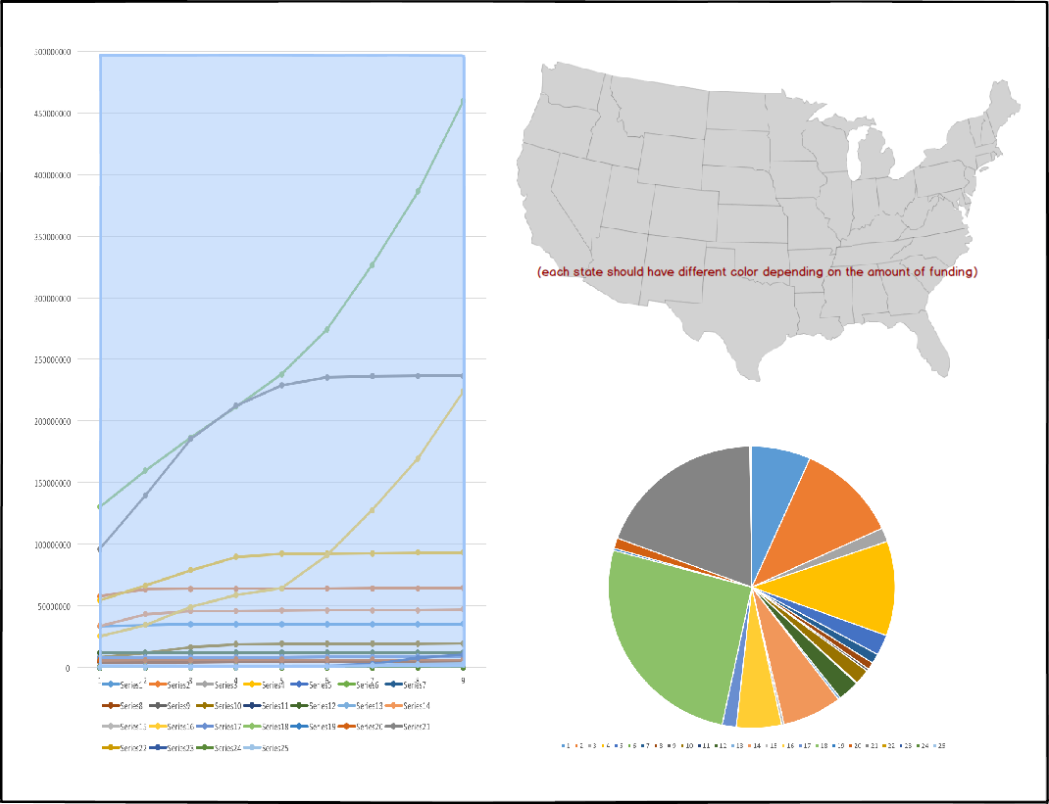

*init state:*

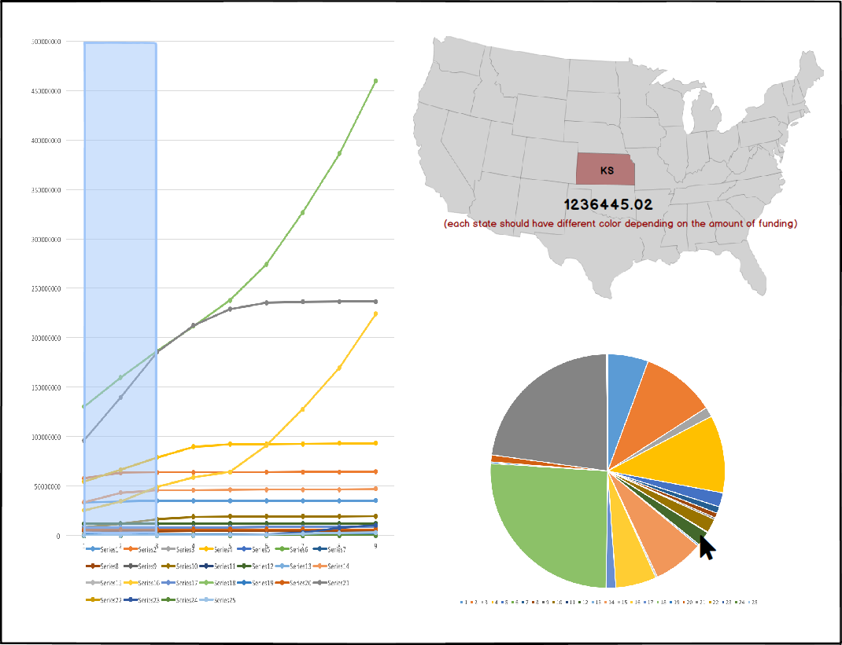

*Click some area in the line chart:*

*Click some candidate button:*

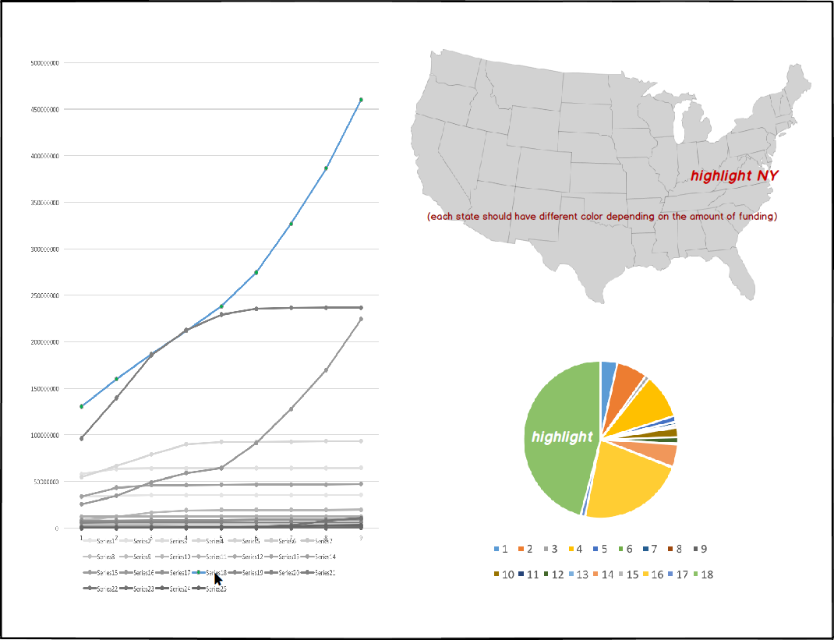

Data structure:

1. For each chart it is a class, where all data are stored and have several states as well as a draw function of its own that will draw differently according to its state.
2. In the draw function of the main class, it will call all the draw functions in each class and pass the state to indicate how each chart should draw itself.
3. The state changes according to the mouse actions.

|  |  |  |  |
| --- | --- | --- | --- |
| State | LINE | PIE | MAP |
| All | Show lines of all candidates | Show the funding of three parties and each has the detail of candidates | Show the total amount of data (to sept) |
| Selected_time | Show lines of all candidates and highlight the selected area | Show the funding of three parties till the end point of highlighted area(details are the same with above) | Show the total amount of data before the XXX |
| Selected_candidate | Show lines of all candidates but only display the line that was selected in the original color, the rest lines are all in a light grey color | Show the ratio of the candidates in the same party with the selected one and highlight the selected one | Show the total amount of data (to XXX) but highlight the state that the selected candidate from |
| Selected_party | Show lines of all candidates but only display the lines that belong to the selected party in the original color, the rest lines are all in a light grey color | Show the ratio of a selected party with the details of the candidates in this party | Show the total amount of data (to XXX) highlight the states that those candidates are from |
| Selected_state | Show lines of all candidates but only display the lines that belong to the selected state in the original color, the rest lines are all in a light grey color | Show the ratio of fundings for the parties from the selected state (with details of each candidate) | Show the amount of data (to XXX) highlight the selected states |

|  |  |  |  |  |
| --- | --- | --- | --- | --- |
| Action | Line | Pie | Map | Button |
| Left click | → Selected_time | → Selected_party | → Selected_state | → Selected_candidate |
| Right click | → All | → Selected_time | → Selected_time |  |